It is also the design pattern for specific problem/use-case
It solves the interview question as it is
It solves the problem of pipeline
Template Method Pattern
Example – suppose you are working on various ML model like decision tree, random forest model, neural network model, SVM so there is a pipeline
Like
Save model
Evaluate
Train model
Preprocess data
Load Data

Whatever the model is you want to follow above steps as it is. And for this you take a help of template method pattern
It also ensure every developer will follow the same steps and don’t shuffle or forget steps, that’s why we provide them the template and tell them to follow this
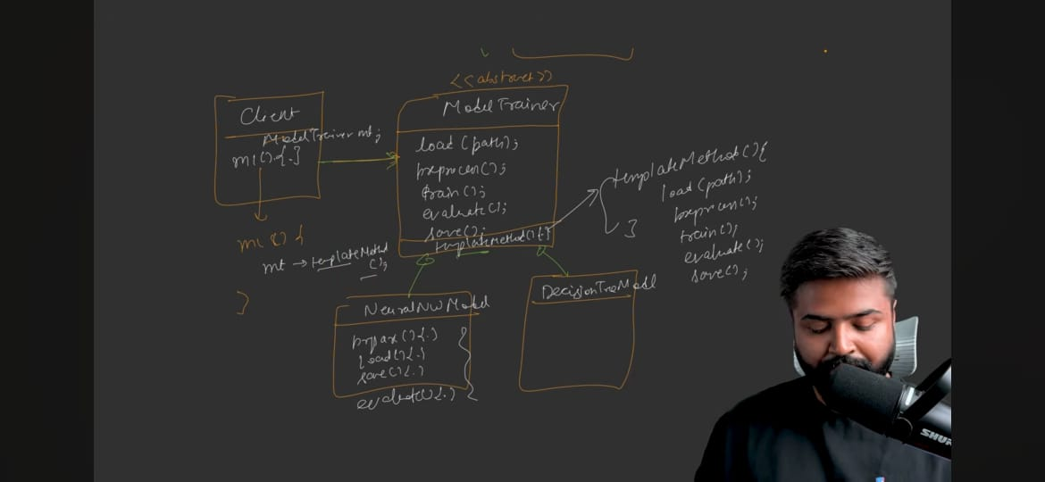
There will be abstract class ‘ModelTrainer’ which will be inherited by all models and they will implement those abstract method by their own ways. This ‘ModelTrainer’ will not be pure abstract method. It has one more method called ‘TemplateMethod()’. In this method we have called the other abstract method in the order we want.
TemplateMethod gives the order of execution
Standard UML Diagram
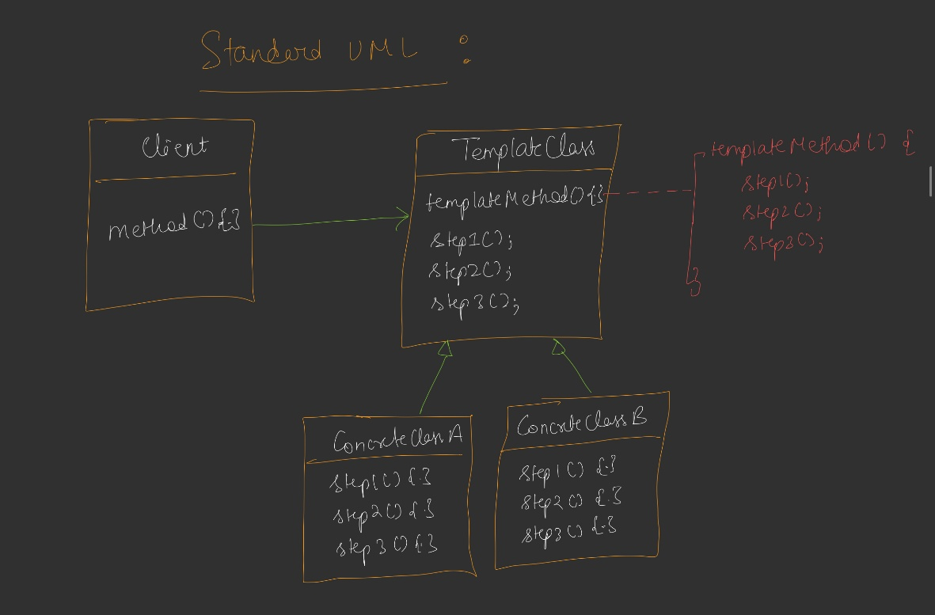
Code – see Notes…………

Standard Defination
Template method pattern design the skeleton of an algorithm, for an operation deferring some steps to subclasses. Template method let subclasses redefine certain steps of an algorithm without changing the algorithm structure
Use cases
- Where order of execution matters –
- Paying UPI – there is a step – validate whether they have that amount or not -> debit -> credit -> validate transaction -> end

